TC-AUTH-019
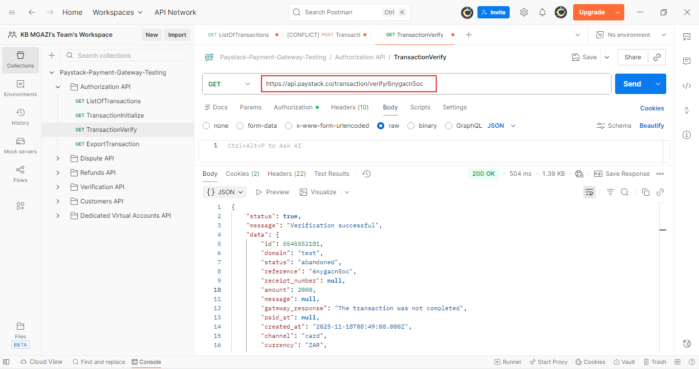
Request:
https://api.paystack.co/transaction/verify/6nygacn5oc

Response:
{
"status": true,
"message": "Verification successful",
"data": {
"id": 5545552181,
"domain": "test",
"status": "abandoned",
"reference": "6nygacn5oc",
"receipt_number": null,
"amount": 2000,
"message": null,
"gateway_response": "The transaction was not completed",
"paid_at": null,
"created_at": "2025-11-18T08:49:08.000Z",
"channel": "card",
"currency": "ZAR",
"ip_address": "105.245.32.160, 197.234.242.122, 172.31.62.52",
"metadata": "",
"log": null,
"fees": null,
"fees_split": null,
"authorization": {},
"customer": {
"id": 319153466,
"first_name": null,
"last_name": null,
"email": "test@example.com",
"customer_code": "CUS_sl8u4vb80xy24wg",
"phone": null,
"metadata": null,
"risk_action": "default",
"international_format_phone": null
},
"plan": null,
"split": {},
"order_id": null,
"paidAt": null,
"createdAt": "2025-11-18T08:49:08.000Z",
"requested_amount": 2000,
"pos_transaction_data": null,
"source": null,
"fees_breakdown": null,
"connect": null,
"transaction_date": "2025-11-18T08:49:08.000Z",
"plan_object": {},
"subaccount": {}
}
}

